**Eser – Esba Tourism**

Western Serbia 7 days

01.06. – 06.06.2024.

(6 day trips)

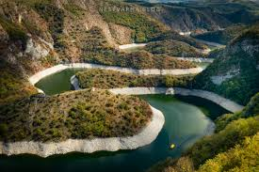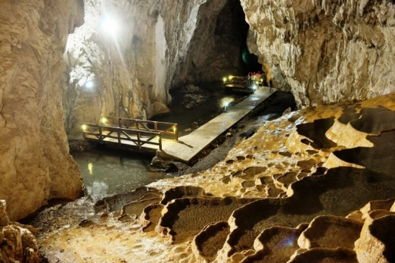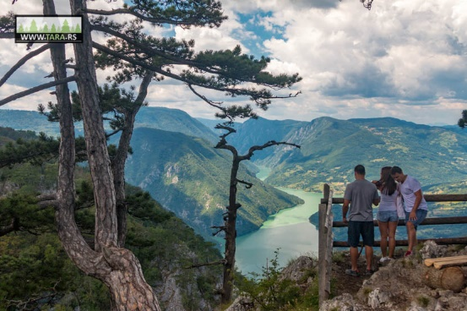

**I day 01.06.2024.**

At 08:20 meeting at lake Perućac, control of travel documents, boarding the boat. From 09:00 till 12:30 cruise through the canyon of the Drina river from Perućac to Višegrad. On the 52 km long voyage, we will enjoy the beauty of nature, the habitats of plant and animal species of the Tara National Park, the confluence of the Žepa River with the Drina River, we will pass through the narrowest part of the canyon, through the Stari Brod camp, next to smaller streams and rivers, medieval fortifications... Arrival in Višegrad at 12:30. Free time for visiting Andrićgrad (Andrić’s town) and the old bridge of Mehmed Paša Sokolović until 14:45. At 15:00 return to Perućac. The expected time of arrival in Perućac is 18:30. Turn back to hotel.

**TOTAL PRICE: 170€** (Transportation, cruising )

**II day 02.06.2024.**

Start from hotel after breakfast at 09:30 and travel to Stopića cave, one of the most famous caves in Serbia well known by its limestone tubs and waterfall inside of the cave. After visiting the cave, short ride to Sirogojno. In Sirogojno village is Open Air Museum „Old village Sirogojno“ where guests can be introduced with Serbian traditional way of life. The selected buildings represent a wealth of architectural and cultural development of Zlatibor region housing, also showing social and economic relations in rural settlements. On 45 minutes ride from Sirogojno there will be also one of the jewels of Zlatibor – Gostilje waterfall. Narrow path from waterfall next to river is rest for soul and body. Next is return toward Zlabior via Ljubiš. Hotel, overnight.

**TOTAL PRICE 235€** ( Transportation, tickets, giude )

**III day 03.06.2024.**

(Optional) At 9:30 departure in front of hotel after the breakfast to starting point of Gold Gondola – longest gondola in the worl from Zlatibor to highest point of mountain Tornik (1496m/asl). Gondola will pass over untouched Zlatibor nature and lake Ribnica. This is the best way to see all beauties of Zlatibor. After Gondola ride, travel toward Mokra Gora. Arrival on main train station of Šargan eight. Narrow guage museum railway from Mokra Gora to Šargan Vitasi will turn guests in the beginning of 20 century when this way of travel was the only one way go somewhere. After 2,5 hours of Šargan eight program next stop is Mećavnik hill and Woodentown- ethno village of famous film director Emir Kusturica and his view on Serbian tradition combined with movie art. Back to hotel.

**TOTAL PRICE 253€** ( Transportation, tickets, guide),( gondola **is not included** , price for gondola is 12€ per person )

**IV day 04.06.2024.**

After breakfast departure toward Nova Varoš and SNR Uvac. Visit to the viewpoint Molitva, then return to Sjenica and spare time. Return to Zlatibor.

**TOTAL PRICE 242€** (Transportation, tickets, guide)

**V day 05.06.2024.**

Departure after breakfast at 9:00. Travel to Tara mountain via Kremna and Kaluđerske Bare toward Mitrovac. Visiting tourist info center and short walk to Carpet medow. Then, short ride and one kilometer long walk to one of the most famous viewpoints on Tara – Banjska stena. Continue to Perućac Lake and river Vrelo (River also known as River Year because of its length of 365m). Ride toward Bajina Bašta. Visiting the symbol of town and river „House on the rock“, spare time in Bajina Bašta. On the way back to Zlatibor short visiting of medieval monastery Rača next to Bajina Bašta.

**TOTAL PRICE 215€** (Transportation, tickets, guide)

**VI day 06.06.2024.**

Hotel, brakfast, continue to Potpeć cave- cave with bigest enterence in Serbia wide and high over 80 m, numerus cave jewelry. Beck to road again and travel to Ovčar Banja, visiting monastery Blagoveštenje. Driving to viewpoint „Pick of Kablar“ with breathless view on meanders of Western Morava River and gorge. Back to Zlatibor.

**TOTAL PRICE 250 € (**Transportation , tickets, guide)

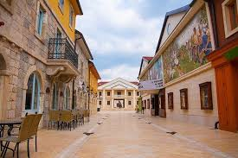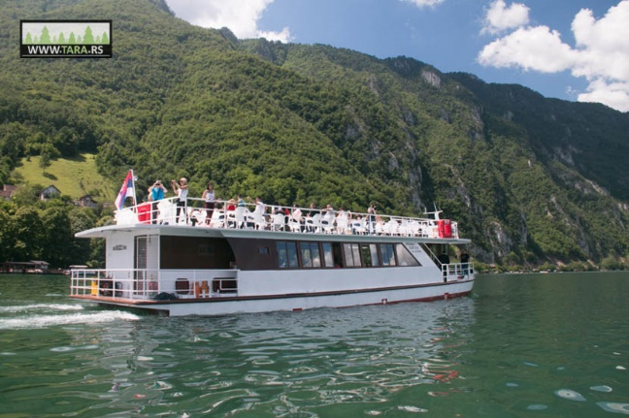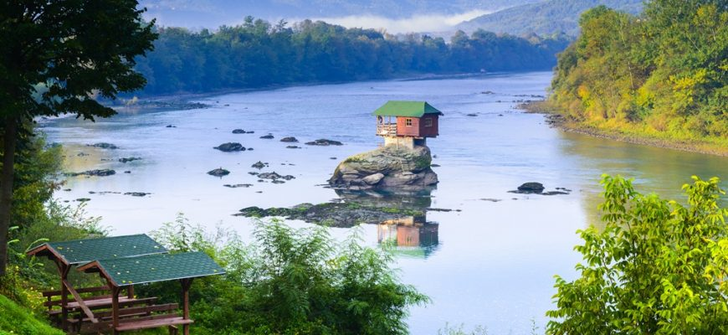

**Program doesn’t include:**

* Gold Gondola tickets
* Lunches,
* Individual coasts,
* All other unmentioned coasts

**Payment**: 30% in advance for reservation confirmation, rest 10 days before arrival.

**Note**:

- Calculation was done on the basis of 3 passengers. In case of a smaller number of passengers, a price correction will follow.

- The agency keeps the right to change the order of services in the case of circumstances that could not have been predicted.

- For all information given verbally or by telephone, agency is not responsible. All information on the website www.taratours.rs are for informational purposes only. Only written travel program and terms and conditions which are available at time of making a reservation are valid.

***Tour package organizer – company “Čiča Gliša” d.o.o – T.A. Taratours***

***80, Svetosavska St. 31250 Bajina Bašta,***

***licensed OTP 26/2023 since 6th April, 2023.***

***T.A. Taratours General Terms and Conditions apply to all travel services***